# Machine Learning-Based Classification of Poultry Diseases for Enhanced Health Management

## Project Description:

This project aims to develop a machine learning-based system for classifying poultry diseases into four categories: Salmonella, New Castle Disease, Coccidiosis, and Healthy. The solution involves creating a robust machine learning model that will be integrated into a mobile application. Farmers will be able to use this application to input data (e.g., symptoms, environmental conditions, and biological samples) and receive an immediate diagnosis along with suggested treatments. The ultimate goal is to provide farmers with a tool that enhances their ability to manage poultry health, thereby reducing disease impact and improving productivity.

### Scenario 1: Outbreak in a Rural Community

A small rural community relies heavily on poultry farming for its livelihood. Recently, the farmers have noticed an increase in sick birds, exhibiting symptoms such as lethargy, diarrhea, and reduced egg production. Without immediate access to veterinary services, the farmers are struggling to diagnose the problem. Using the new mobile application, they input the observed symptoms and environmental data. The machine learning model quickly classifies the disease as Coccidiosis and provides recommendations for treatment and management. This allows the farmers to take swift action, reducing the spread of the disease and preventing further economic losses.

### Scenario 2: Commercial Poultry Farm Management

A large commercial poultry farm has implemented the machine learning-based disease classification system to monitor the health of its flocks. Daily health checks are performed, and data is collected via the mobile application. One day, the system identifies symptoms consistent with New Castle Disease in a specific section of the farm. The early detection enables the farm management to quarantine the affected birds and implement control measures promptly, preventing a widespread outbreak and ensuring the overall health of the flock. This proactive approach not only saves costs but also maintains the farm's productivity and reputation.

### Scenario 3: Research and Training for Veterinary Students

A veterinary school integrates the machine learning-based disease classification application into its curriculum. Students use the app to input data from case studies and real-world scenarios. Through this hands-on training, they learn how to diagnose diseases like Salmonella, New Castle Disease, and Coccidiosis using modern technology. The application also provides detailed information about each disease, treatment options, and management practices. This experience equips future veterinarians with valuable skills in utilizing advanced diagnostic tools, preparing them to better serve the poultry industry.

## Technical Architecture

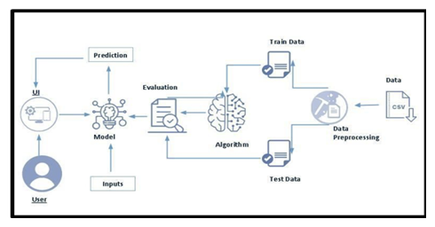

## Project Flow:

* User interacts with the UI to enter the input.
* Entered input is analysed by the model which is integrated.
* Once model analyses the input the prediction is showcased on the UI

**To accomplish this, we have to complete all the activities listed below:**

* **Data Collection & Preparation** 
  + Collect the dataset
  + Data Preparation
* **Exploratory Data Analysis** 
  + Descriptive statistical
  + Visual Analysis
* **Model Building** 
  + Training the model in multiple algorithms
  + Testing the model
* **Performance Testing** 
  + Testing model with multiple evaluation metrics
  + Comparing model accuracy before & after applying hyperparameter tuning
* **Model Deployment** 
  + Save the best model
  + Integrate with Web Framework

**Prior Knowledge:**

You must have the prior knowledge of the following topics to complete this project.

* Transfer learning : https://www.geeksforgeeks.org/ml-introduction-to-transfer-learning/
* Decisiontree:<https://www.geeksforgeeks.org/python-decision-tree-regression-using-sklearn/>
* Random forest: <https://www.geeksforgeeks.org/random-forest-regression-in-python/>
* Flask Basics: [https://www.youtube.com/watch?v=lj4I_CvBnt0](http://www.youtube.com/watch?v=lj4I_CvBnt0)

## Milestone 1: Data Collection

**Create API Token on Kaggle**

* Log in to your Kaggle account.
* Go to your account settings and select "Create New API Token."
* This will download a kaggle.json file containing your API credentials.

**Set Up Google Colab Environment**

* Open a new notebook in Google Colab.

**Upload kaggle.json to Colab**

* Upload the kaggle.json file to your Colab notebook. This file contains your Kaggle API credentials.

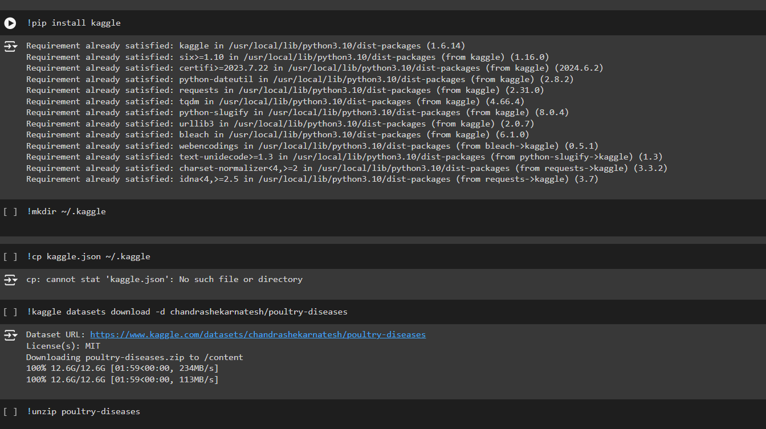

## Dataset: [Link](https://www.kaggle.com/datasets/chandrashekarnatesh/poultry-diseases)

### 1.1Activity: Import libraries

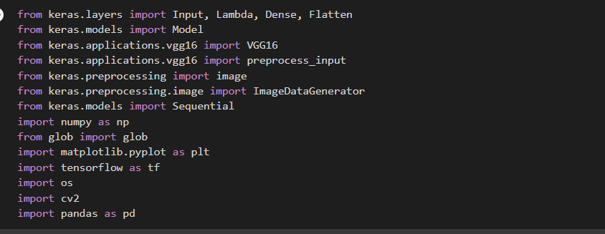

This code uses the VGG16 architecture from Keras for transfer learning to classify images of poultry diseases. It preprocesses the images, creates a model with VGG16 as the base, and adds custom dense and flatten layers for classification. The model is then trained using images loaded from directories with the help of ImageDataGenerator.

### 1.2 Activity: Define the paths for train , test and validation data

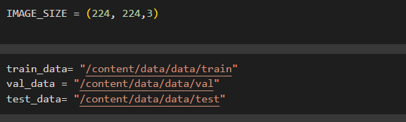

Describing the **Image size**  , and assign the paths .

### 1.3 Activity:

The read_data function reads a subset of images from a specified folder, taking 500 images per label category. It iterates through each label, loads the images using OpenCV, and collects the image data, labels, and file paths into separate lists. This function is designed to manage large datasets by processing a smaller, manageable subset of images for training, validation, or testing.

We have taking 500 images from all 4 categories for training, testing and val because in each dataset from training , testing and validation there 4 lakhs , 70k and 40k. Those are very huge data to train we don’t have that much ram in so collect 500 from each of the folder.

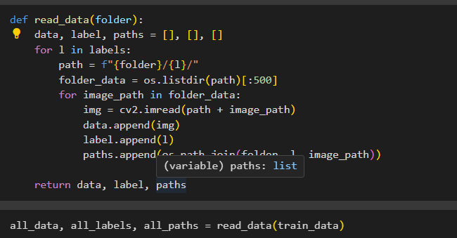

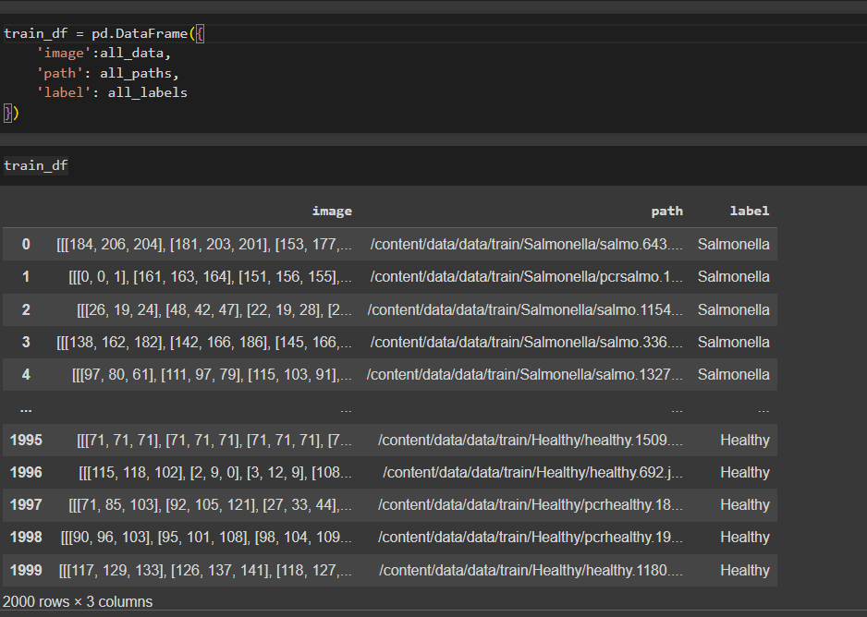

Perform above operations for test and validation data also

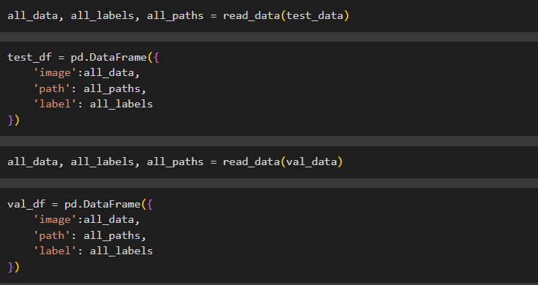

## Milestone 2: Using ImageDataGenerator